PROBLEM
Oh no!
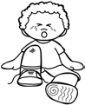


STEPS to SOLVE the PROBLEM
Series of Events
CLIMAX EVENT! Turning Point
BANG!

