
‘THE LITTLE RAINDROP’
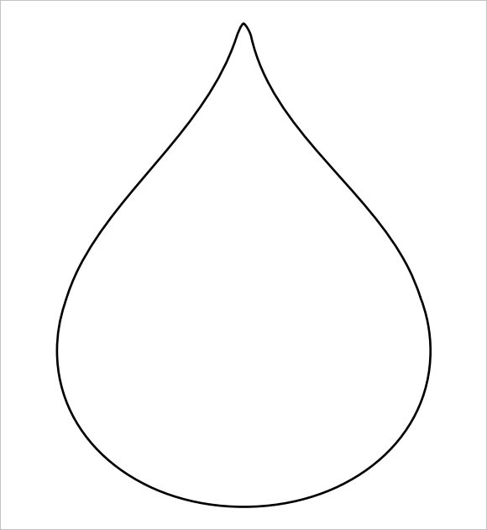
Draw and label the places the little raindrop went on his journey. Cut and paste them in order.

The _____________

The _____________

The _____________

The _____________

The _____________

The _____________

The _____________

The _____________

